This is the article template for Filologicheskie nauki v MGIMO / MGIMO Journal of Language Research and Learning

Article type (Research Article, Review Article, Book Review, Academic Life)
UDC (see https://teacode.com/online/udc/)
DOI: to be assigned by the editorial office.

Article Title (5–12 words)

Given Name Surname of Author ¹
Given Name Surname of Co-author ²

¹ Affiliation of Author 1: University / Institution, City, Country (numbers before the affiliation are used when there are two or more authors)
² Affiliation of Author 2: University / Institution, City, Country

Abstract. The abstract should be 300–350 words long. Typeface: Times New Roman; font size 14 pt; line spacing 1.5; justified alignment; no paragraph indentation. The abstract is not divided into paragraphs. The structure of the abstract should logically reflect the IMRaD structure of the article and include the following points: relevance, materials and methods, results, and conclusions.

Keywords: 5–7 keywords or phrases that accurately reflect the research topic. Avoid general terms such as “pedagogy” or “language.” Separate keywords with commas.

For citation: Ivanov I. I. Nazvanie statyi [Title of the Article in English]. Filologicheskie nauki v MGIMO. 2026.

The Russian-language abstract and keywords are provided below. For authors who do not speak Russian, the abstract in Russian will be prepared by the journal's editorial office.

Заголовок статьи (8-15 слов)

И.О. Фамилия 1 автора ¹
И.О. Фамилия 2 автора ²

¹ Аффилиация 1 автора: Вуз, город, страна (цифры перед аффилиацией указываются, если авторов 2 и более)
² Аффилиация 1 автора: Вуз, город, страна

Аннотация
Объем русскоязычной аннотации 250-300 слов. Шрифт Times New Roman, кегль 14 пт, междустрочный интервал 1,5, выравнивание по ширине, абзацный отступ отсутствует. Текст аннотации не делится на абзацы. Структура аннотации должна логично отражать структуру статьи по IMRAD, и содержать следующие пункты: актуальность, материалы и методы, результаты и выводы.

Ключевые слова: 5-7 ключевых слов или словосочетаний, точно отражающих тему исследования. Рекомендуется избегать общих терминов, таких как «педагогика», «язык». Ключевые слова разделяются между собой запятыми.

Для цитирования: Автор 1, Автор 2. Заголовок статьи // Филологические науки в МГИМО. 2026.

The main text of the article is structured according to IMRaD (Introduction, Materials and Methods, Results and Discussion, Conclusions). Each section is numbered manually (1. Introduction, etc.); automatic section numbering is not allowed. A blank line is left before and after each section ([blank line] 1. Introduction [blank line] Text).
The article text is typed in Times New Roman, font size 14 pt, line spacing 1.5, justified alignment, paragraph indentation 1.25 cm (not set by Tab). Throughout the text, please disable widow/orphan control and word hyphenation. Examples provided in the text are highlighted using italics or bold italics; underlining is not allowed. All examples, illustrations, and tables must contain source references as footnotes if they were not compiled by the author, and must also be referenced in the text, for example: see Table 1.
The length of a research article is 40,000–60,000 characters including spaces. The length of a review article is 60,000–80,000 characters including spaces.

1. Introduction

In the Introduction, the author should outline the relevance and purpose of the study, review previous research, identify the gap that the study fills, and state the scholarly contribution of the work. The text should not contain a simple listing of scholars’ names without analysis of specific works and references to their publications. Here and throughout the article, surnames and initials of cited authors are separated by a non-breaking space (Ctrl+Shift+Space).

2. Materials and Methods

This section provides a quantitative and qualitative description of the research materials and the methods used to analyze them, outlining the sequence of research stages (the justification for applying particular methods of analysis to the material and to the results obtained).

3. Results and Discussion

This section presents the results and the author’s interpretation of them. The text may contain subheadings indicating thematic parts of the research (e.g., 3.2. Analysis of…). The inclusion of informative examples, figures, tables, and charts accompanied by the author’s commentary is encouraged. The section should conclude with a description of the limitations of the study (limitations related to the sample or materials, the methods used, the units analyzed, etc.).

Examples of formatting for included elements:

Textual examples

… as shown in example (7) / … example (10) demonstrates:
(7) Russian. Я видел кошку.
‘I saw a cat.’ (Here and throughout, translations are mine. — Author’s Initials)

(10) Udmurt. Мон вуэ.
‘I am going.’ (from the book: Author. Title. Publisher, year.)

Figures, Tables, Charts

… as shown in Table 2 … / … Figure 1 demonstrates … / … depicted in Chart 3 …

Table 1. Table title (above the table, justified alignment, bold font; the table is center-aligned with no text wrapping; font size inside tables may be reduced to 10 pt).
Translation technique | Medicine | Engineering | Sociology / Education
Participial construction | 36% | 30% | 44%
Omission of predication | 29% | 28% | 42%
Calque | 16% | 28%
Verbal noun | 23% | 14% | 20%

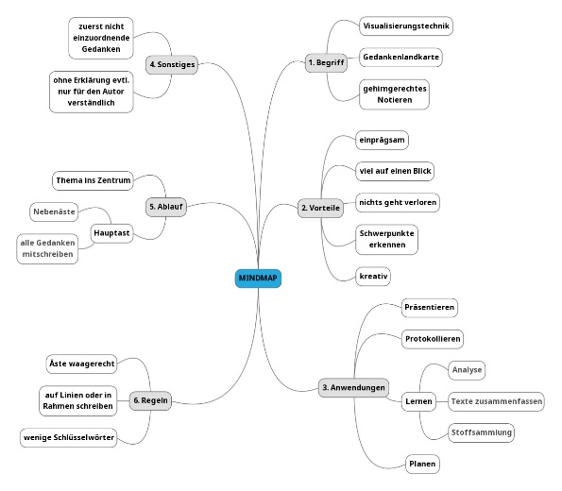
Fig. 2. Figure title (below the figure, justified alignment; the figure is aligned in line with the text, no text wrapping).

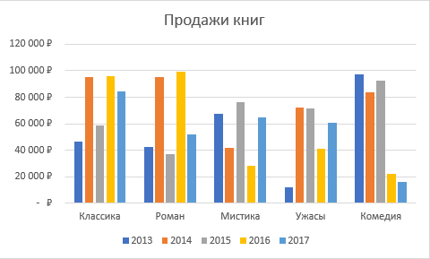
Chart 3. Chart title (below the chart, justified alignment; the chart is center-aligned; the chart includes a data legend).

4. Conclusions

The order of conclusions should match the order in which the results were presented in the previous sections. The section begins with a brief summary of the research results, followed by section-specific conclusions. The section concludes with the theoretical and practical significance of the study, as well as directions for further research.

Acknowledgements (optional, not numbered)

The authors thank [names and organizations] for their assistance with [data collection, transcription, annotation, statistical advice]. The research was supported by [grant No. … from …].

Conflict of Interest (not numbered)

The author declares no conflict of interest.

References (Russian-language list)

The reference list includes only scholarly sources. Other sources (journalistic and literary texts, lexicographic sources, internet publications, web pages, corpora, legislative and regulatory acts, etc.) are formatted as page-level footnotes. It is recommended to exclude textbooks and teaching aids from the reference list and to replace references to dissertations with references to avtoreferaty (dissertation synopses), where available. The reference list is presented in alphabetical order and is not numbered. The author’s surname and initials are separated by a non-breaking space (Ctrl+Shift+Space). The reference list should contain no fewer than 23 sources for a research article, including at least 5 works published in the last 5 years; for a review article — no fewer than 50 sources, including at least 10 from the last 5 years. Each cited source must have a DOI (where assigned; typically for publications from 2000 onwards). Formatting: use a 1 cm hanging indent; spacing before and after 0 pt. If an article has no DOI, please provide the EDN (identifier from the eLibrary database).
Examples of source formatting:
Book, monograph
Ахманова О. С., Гюббенет И. В., Идзелис Р. Ф. Принципы и методы лексикологии как социолингвистической дисциплины. Москва : Издательство МГУ, 1971. 137 с.
Chapter in a book or monograph
Глушак В. М. Языковая реализация качества в группе существительного в немецком языке // Современные тенденции в германском языкознании: особенности вербализации смыслов. Москва : Московский государственный областной университет, 2017. С. 223–280.
Article in a periodical
Конколь М. М. Метацифровая компетентность как новая парадигма образования в эпоху искусственного интеллекта // Ученые записки Российского государственного социального университета. 2025. Т. 24. № 2 (175). С. 112–119. https://doi.org/10.17922/2071-5323-2025-24-2-112-119
Article in a collected volume
Анисимов В. Е., Анисимова Е. Д. Применение субвидемы «Шортс» в рамках профессионального обучения студентов иностранному языку // Евразийский взгляд на актуальные вопросы филологии, переводоведения и лингводидактики : сборник статей по материалам III Евразийской научно-практической конференции, Москва, 29 ноября 2024 года. Москва : Российский государственный социальный университет, 2025. С. 18–21.
Collected scholarly works
Лингвистика и поэтика : сборник научных трудов. Московский педагогический государственный университет, кафедра русского языка. Москва : Центр гуманитарной литературы, 2005. 27 с.
Article in an electronic publication (Russian or foreign language)
Wagner C. W., Semper S., Kirchhof J. Fastmat: Efficient Linear Transforms in Python // SoftwareX. 2022. Vol. 18. URL: https://www.sciencedirect.com/science/article/pii/S2352711022000218 (дата обращения: 08.09.2025).
Foreign-language article in a periodical
Langacker R. W. A View of Linguistic Semantics // Language. 2020. Vol. 96, No. 3. P. 542–578. https://doi.org/10.1353/lan.2020.0045
Foreign-language book or monograph
Chomsky N. Aspects of the Theory of Syntax. Cambridge, Mass. : MIT Press, 1965.
Chapter in a foreign-language book or monograph
Lakoff G. The Contemporary Theory of Metaphor // Metaphor and Thought / ed. by A. Ortony. 2nd ed. Cambridge : Cambridge University Press, 1993. P. 202–251.
Foreign-language dissertation
Smith J. A. Discourse Markers in Spontaneous Speech : Thesis … Doctor of Philosophy. Cambridge, MA : Harvard University, 2015.

References (English-language list)
The References list is not numbered and is arranged according to the Latin alphabet (it may differ from the Russian-language source list). Formatting style: APA Style. For works by Russian-language authors, first provide the transliteration of the title according to the transliteration rules specified by the journal (see Author Guidelines, section on transliteration; https://translitonline.com/, http://translit-online.ru/), then the official translation of the title in square brackets (not the author’s own). Journal titles are given in English as shown on the publishers’ official websites.
Examples of source formatting:
Book, monograph in Russian
Karasik, V. I. (Ed.). (2005). Aksiologicheskaya lingvistika: lingvokul’turnye kontsepty [Axiological linguistics: Linguocultural concepts]. Paradigma. (In Russian)
Chapter in a book in Russian
Glushak, V. M. (2017). Yazykovaya realizatsiya kachestva v gruppe sushchestvitel’nogo v nemeckom yazyke [Linguistic realization of quality in a noun group in German]. In Sovremennye tendentsii v germanskom yazykoznanii: Osobennosti verbalizacii smyslov (pp. 223–280). Moskovskiy gosudarstvennyy oblastnoy universitet. (In Russian)
Article in a journal
Konkol, M. M. (2025). Metatsifrovaya kompetentnost’ kak Novaya paradigma obrazovaniya v epokhu iskustvennogo intellekta [Metadigital Competence As a New Educational Paradigm in the Era of Artificial Intelligence]. Uchenye zapiski Rossiyskogo gosudarstvennogo sotsial’nogo universiteta, 24(2), 112–119. https://doi.org/10.17922/2071-5323-2025-24-2-112-119 (In Russian)
Article in a collected volume
Anisimov, V. E., & Anisimova, E. D. (2025). Primenenie subvidemy «Shorts» v ramkah professional’nogo obucheniya studentov inostrannomu yazyku [Application of the Shorts subvideme in the framework of professional foreign-language teaching]. In Evraziyskiy vzglyad na aktual’nye voprosy filologii, perevodovedeniya i lingvodidaktiki (pp. 18–21). Rossiyskiy gosudarstvennyj social’nyy universitet. (In Russian)
Edited volume
Editor, J. J., Editor, A. A., & Editor, P. P. (Eds.). (2012). Book title: And subtitle. Smith Publishing.
Article in an electronic publication
Wagner, C. W., Semper, S., & Kirchhof, J. (2022). Fastmat: Efficient linear transforms in Python. SoftwareX, 18. https://www.sciencedirect.com/science/article/pii/S2352711022000218
Article in a foreign-language periodical
Langacker, R. W. (2020). A view of linguistic semantics. Language, 96(3), 542–578. https://doi.org/10.1353/lan.2020.0045
Book or monograph
Chomsky, N. (1965). Aspects of the theory of syntax. MIT Press.
Book (authored monograph)
Lakoff, G., & Johnson, M. (1980). Metaphors we live by. University of Chicago Press.

About the author

Given Name Surname, academic degree, academic status, position at University / Institution (City, Country). Research interests: 5–7 keywords.
E-mail: …
ORCID: https://orcid.org/...

